Understanding the User

2.6: Task Analysis & User Flows

Learning Goals

* Select important user stories from the journey map
* Create user flows for each of those tasks

 Estimated Read Time: 30 Minutes.

Introduction

Nice to see you again and welcome to Exercise 2.6! In the last Exercise, you created your first user journey maps, and while it was a time-consuming process, hopefully it helped you recognize how useful such a document can be for communicating and solving problems throughout the design process.

In this Exercise, we’re going to explore user flows, another critically important document in helping us understand the needs of our users. You had a chance to create some basic user flows and task analyses for your vocabulary app in the Fundamentals Course. Now, let’s take an even closer look at how best to use these methods. First, we’ll review the components of a user flow. Then, we’ll move onto a technique called task analysis for some help in brainstorming your first user flows.

Finally, we’ll discuss in detail best practices for creating your own user flows via step-by-step examples with our travel guide demo app. At the very end of the Exercise, you'll also find a video demonstrating how to create user flows in Google Drawings. Let’s get to it!

What Is a User Flow?

A **user flow** is a diagram or map of pages a visitor must interact with to complete a task or achieve a goal on a given website or application. The “flow” part of user flow is important; rather than a list of screens or pages, user flows have a beginning and an end and follow a user’s progress throughout the diagram.

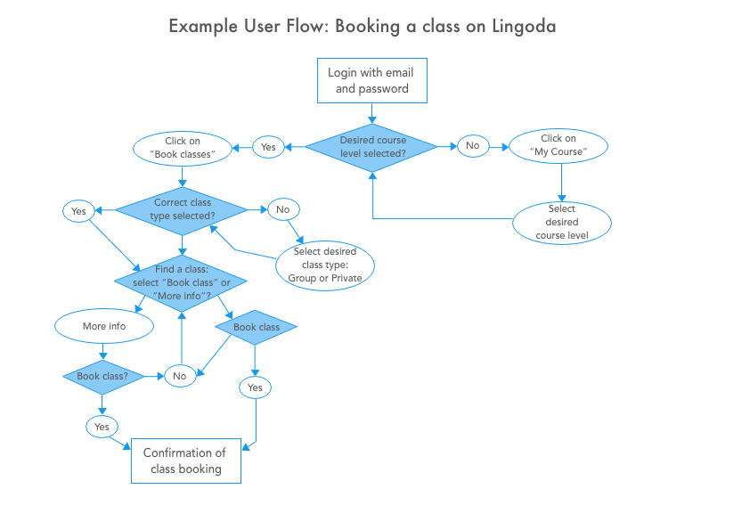

[Click here](https://s3.amazonaws.com/coach-courses-us/public/courses/ux-immersion/A2/E6/A2E6_exampleuserflow.png) to zoom in

User flows are commonly one of the last pieces of documentation created before heading into the information architecture phase of user-centered design. This is because we need to determine a few key things about our project before we can create an effective user flow:

* As personas and their needs will help inform the creation of your user flows, you should already have a solid set of personas before starting.
* You need to know about the types of actions your users will take, as well as why they take those actions, before you can create a successful user flow.
* In addition to the objectives of your personas, you need to understand the objectives of the business behind your project. While this hasn’t played a big role in ths
* is course, it’s important to note for your professional career. Balancing user needs with business objectives is an important role of the UX designer, and we’ll be discussing that balance throughout this Exercise.

Why Create User Flows?

While not all projects will have the budget or time necessary for user flows (it’s your job as a UX designer to push for that time and budget whenever you can), those that do will benefit in a number of ways.

First, user flows help designers avoid a common mistake in product development—too much focus on individual pages and interactions within an app. Taking a step back and concentrating on user flows rather than individual pages will make your design more user-centered and, therefore, more successful from your users’ point of view. Your users are, after all, the ones you’re trying to please!

Second, user flows are one of the best tools for discovering what pages or screens of an app are needed before you begin the information architecture phase of your project. By walking through their own user flows from their personas’ points of view, designers are able to ensure that their personas’ every need has been satisfied at every point in the user flow. No matter what a persona may need, there will be a screen or page to accommodate them.

For a great article on designing flows before pages, check out [Stop Designing Pages and Start Designing Flows](https://www.smashingmagazine.com/2012/01/stop-designing-pages-start-designing-flows/).

Staying User-Focused

Before diving straight into your user flows, let’s touch quickly on that balancing act mentioned above. Have you ever arrived on a new website only to be greeted with a modal window, blocking out all of the website’s content and asking that you sign up for a newsletter, coupon, or something similar? Designs like this are obviously business-focused—it would be pretty hard to find a user who actually needed or wanted this kind of in-their-face pop-up, after all. While business objectives are important to the success of your app or product, they oftentimes don’t align with the needs of your personas.

When designing your user flows, the needs of the user should always come first, and it’s your job as a UX designer to advocate for the user in a world focused on business needs. Every team is going to have slightly different priorities, so it becomes a sort of ongoing balancing act; however, UX designers who do their research thoroughly benefit from data that shows that user-centered design not only makes users happier but creates more conversions, as well, which leads to a winning scenario for everyone involved.

Task Analysis

Now that we’ve gone into what comprises a user flow, let’s look at the best ways of *building* a user flow. **Task analysis** is a simple process that helps UX designers determine what tasks are required for the completion of a goal, usually in the context of a persona. For the purpose of this Exercise, let’s go with our high-energy millennial persona mentioned in Exercise 2.4. You, however, should keep in mind one of your own personas. This is a great opportunity to compare each step of the demo persona with the persona for your own project, as that’s exactly who’ll you be creating user flows for in this Exercise’s Task!

What’s the Objective?

To begin your task analysis, you’ll first need to define a few objectives for your persona. Remember when you created user stories in the UX Fundamentals Course? That process will be incredibly useful here, as well!

As a quick refresher, let’s revisit the typical format of a user story:

**As a** [persona], **I want** [some action], **so that** [outcome].

Now, let’s fill in the blanks with our persona, who in this Exercise will be named “Maggie.” We know that Maggie is a high-energy person and a young adult interested in being social and exploring travel destinations. In the case of our demo app, an appropriate user story might go something like this:

**As a** socially-active young adult, **I want** to find interesting nightlife during my trip to Berlin, **so that** I can meet new and interesting people.

Great! We now have an objective for our user flow, which means it’s time to move onto our task analysis and expand this aim into something we can work with.

TIP!  
When creating your own objectives, use tasks that would hold importance not only as user objectives but as business objectives, as well. In the demo project, for example, we know that our goal is an app that provides travel guides to users. This is a business objective, but it also aligns nicely with Maggie’s objective as a user. Take a look at the user journey maps you created in the last Exercise for help in determining these kinds of multi-function objectives.

Information Gathering

Task analysis begins with a bit of information gathering. We need to know more about our persona if we’re going to have enough context to create a user flow. Using your persona as a guide, ask yourself the following questions:

* What is it that’s prompted my persona to begin the task?
* What will tell the persona that their task is finished?
* What information does the persona already know about the process?
* What additional information does the persona need to know to complete the task?
* Finally, what tools will the persona need to complete the task?

Let’s see if we can answer these questions using our demo persona, Maggie, and build a context for our task analysis.

* Maggie has been prompted to begin the task because she has an upcoming visit to Berlin planned.
* Maggie will know her task is finished because she will have found an ideal guide to the nightlife of Berlin!
* We know that Maggie is tech-savvy and probably knows the basics of travel, having traveled fairly frequently in her life. She also knows how to recognize useful information online or in apps. If we can simply lead her to good information, she’ll be successful.
* Maggie needs to know about what travel guides are available and relevant, as well as how to find them.
* Maggie should only need to use our demo app to complete the task, so let’s make sure we include all the features she needs.

Creating Your Task Flow

All right! Now that we have a context to work with, all we need to do is document the processes Maggie will use to complete her task within our app. With your persona and objective in mind, walk yourself through all of the individual steps needed to complete the objective within the context we just established.

Remember the task analysis from Exercise 4 of the Fundamentals Course on how to make a cup of tea? Let’s revisit these steps, only this time, applying them to our persona Maggie. The task flow would look something like this:

* **Entry point** (where Maggie would first encounter the task): Download the app
* **Success criteria** (what successful completion of the task would look like): Read the guide

1. Launch the downloaded app
2. Make an account with the app
3. Log into the app
4. Decide on a desired destination
5. Find a way to search for travel guides
6. Search for travel guides that have something to do with nightlife
7. Find the nightlife travel guides that focus on Berlin
8. Download or save the guide she likes
9. Read the guide to inform herself

While our numbered list is a fine way to record a task flow, many times the tasks will be very complex and require a workspace and sticky notes to work out the details. Here’s another example using this process (with some great storyboarding as well!):

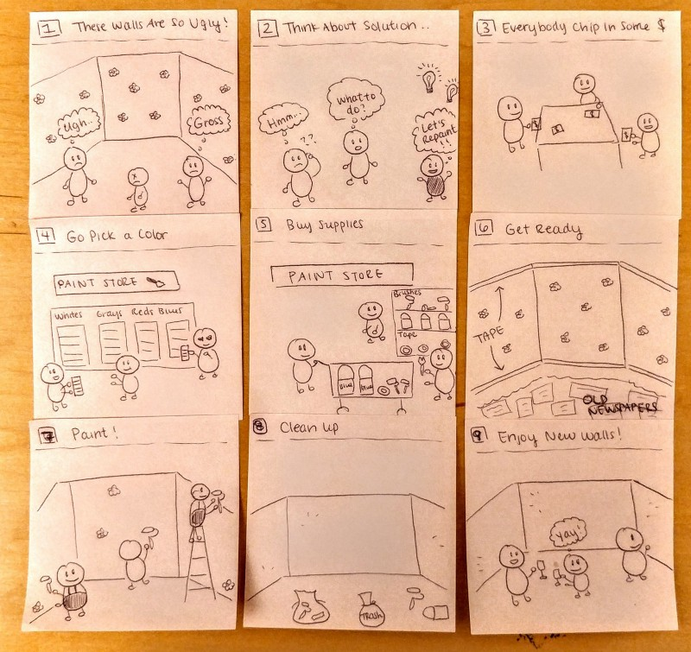

Source: [Medium](https://medium.theuxblog.com/task-analysis-mapping-2117a5e4f6fa#.avfm2275d). Analysis of the task “Painting a room”

Optimizing Your Task Analysis

Now that we have a good task flow to start with, it’s time to optimize by simplifying the list. Your goal with optimization should be to consolidate the list to as few and as simple of steps as possible while still meeting the needs of your persona. It’s also important to recognize the scope of your project and that it may not be able to satisfy every part of your task analysis.

In our example, since we can’t really control the downloading and installation of our app (that’s more of a marketing task), we can remove those elements for the purposes of a user flow. In addition, even though Maggie will definitely want to read the guide at some point, as long as we provide it to her in our user flow, the app’s job is done. We can remove that step as well, giving us the following final task analysis:

1. Make an account with the app
2. Log into the app
3. Find a way to search for travel guides
4. Search for travel guides that have something to do with nightlife
5. Find the nightlife travel guides that focus on Berlin
6. Download or save the guide she likes

Creating User Flows

Once you’ve followed the task analysis process, creating user flows simply becomes a way of adding in the context of your project and visualizing the task analysis in a way that’s easier to communicate. As with many documents in the UX industry (including several you’ve already worked on!), there’s no single correct way to document a user flow. The key is to document your persona’s objective as a path using the screens of your app or pages of your website. Let’s turn once again to our demo app example and watch our user flow come to life.

Incorporating Your Task Flows

The first step in creating your user flow is to incorporate your task analysis into the document. In this case, for example, we know that the first step is to “make an account with the app.” As a UX designer, you can conclude that some type of page or screen will be necessary to make that account, and that screen will be the first screen of your user flow. Each page or screen in the flow is represented as a box, and the direction of the flow is denoted with arrows.

Continue doing this for every step in your task analysis until a diagram that looks something like the following takes shape:

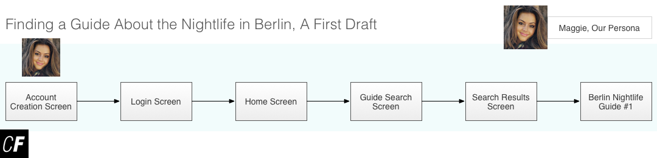

Our first draft, based on task analysis. [Click here](https://s3.amazonaws.com/coach-courses-us/public/courses/ux-immersion/A2/E6/A2E6_basicuserflow.png) to zoom in

Very interesting and informative, right? Just by looking at this flow, we can tell that our app will need at least six screens to meet the needs of our persona. Now, it’s time to do some detective work and think about what else might be needed in our user flow to increase its usefulness even further.

Revising Our User Flow

While our current user flow is accurate and meets some of the needs of our persona, it doesn’t include everything that could happen as Maggie navigates our app. For instance, what happens if Maggie forgets her password? It happens to everyone from time to time, and Maggie is a busy persona with a lot on her mind! Let’s add another screen so that users who forget their passwords will have a place to reset them:

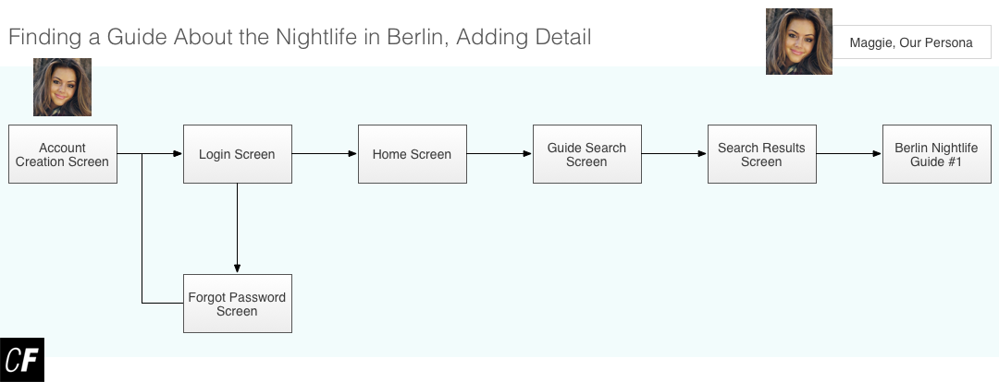

[Click here](https://s3.amazonaws.com/coach-courses-us/public/courses/ux-immersion/A2/E6/A2E6_userflowfirstoption.png) to zoom in

Looking good! The arrow from the “Forgot Password Screen” returns to the original flow, indicating that Maggie will be returned to the “Login Screen” after resetting her password. It’s important to accurately document these types of paths in your flow as accurate flows promote communication within your product team and speed up the design process.

What other hiccups might Maggie encounter as she tries to use our app? We know that Maggie and other users like her are pretty tech savvy, but sometimes even tech savvy users need a little help figuring out how something works. What if we added a bit of onboarding (in-application help) for users who aren’t sure where to go first? This would be a great addition to the home screen (where most users would expect to find help if needed). We can also add in more detail at the end of our flow where we have Maggie locate her guide on Berlin nightlife. What if there’s more than one result that matches her search? By adding in a few more options, we make the user flow more complex and more accurate.

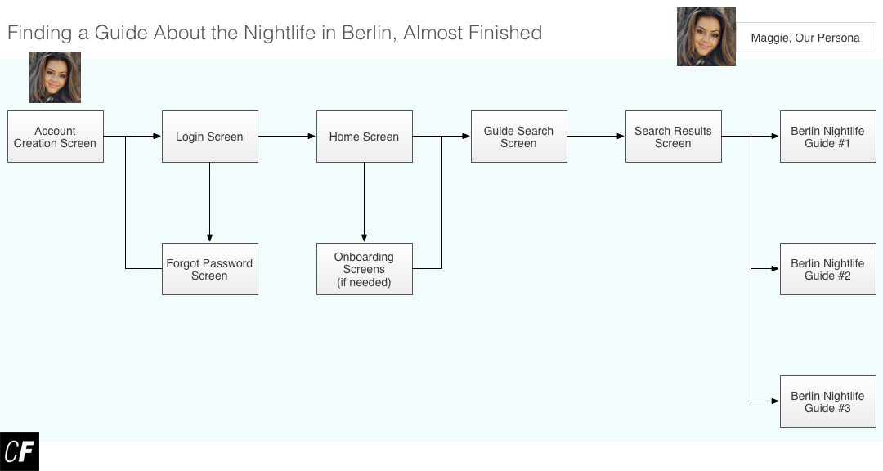

[Click here](https://s3.amazonaws.com/coach-courses-us/public/courses/ux-immersion/A2/E6/A2E6_userflowoptions.png) to zoom in

Our user flow is now full of options Maggie may take in order to complete the task—onboarding if she needs it, three possible search results (the number here isn’t important; just showing that possible paths exist is enough), and even a path to help her recover a forgotten password. There is, however, one final addition that could make our user flow even *more* useful—labels. Why don’t we take a moment to add a few more details to our user flow:

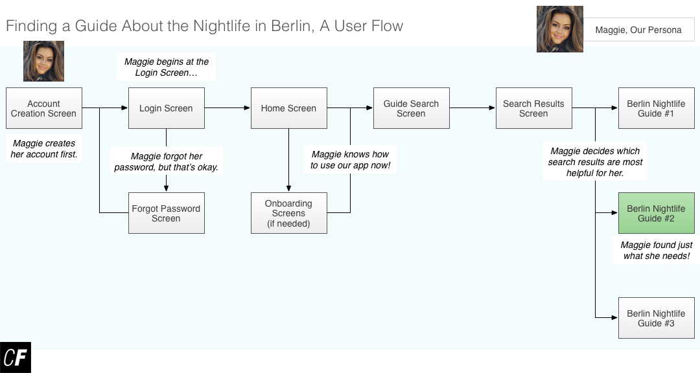

[Click here](https://s3.amazonaws.com/coach-courses-us/public/courses/ux-immersion/A2/E6/A2E6_completeuserflow.png) to zoom in

There! *That’s* a useful user flow! At this point, a UX designer will go on to repeat this process for all of his or her personas, creating user flows for each persona’s primary objectives. With such documentation in hand, they’re well on their way to creating a sitemap, something that we’ll be covering in Exercise 3.2. For now, however, consider your personas and think about what user flows would be most useful for your project as you approach the task for this Exercise.

For more on this topic, check out the instructional video below on how to create user flows in Google Drawings:



Summary

In this Exercise, we discussed user flows and the benefits to creating them for your projects. We then covered how to create them using your task analysis as a stepping stone before walking through a few concrete examples.

In our next Exercise, we’ll be covering the concept of mobile-first design, an interesting and useful thought process in the age of responsive UX, but for now, it’s time to create some user flows for your own project!

Resources

* [Creating Perfect User Flows for Smooth UX](https://www.uxpin.com/studio/blog/creating-perfect-user-flows-for-smooth-ux/)
* [How to Improve Your UX Designs with Task Analysis](https://www.interaction-design.org/literature/article/task-analysis-a-ux-designer-s-best-friend)

Take the quiz to test your knowledge on this Exercise.

Take Quiz

Task

* [DIRECTIONS](https://careerfoundry.com/en/course/become-a-ux-designer/exercise/task-analysis-and-user-flows#directions)
* [SUBMISSION HISTORY](https://careerfoundry.com/en/course/become-a-ux-designer/exercise/task-analysis-and-user-flows#step_submission_history)

 Estimated Task Time: 5 Hours.

Using what we’ve discussed in this Exercise, create 3 user flows for your project. You can use 3 flows from one persona or create user flows from a selection of personas. The requirement is 3 user flows total.

Be sure to use the key objectives from each of your personas. There are many types of tools you can use to create your user flows, but some of the most popular are Sketch, OmniGraffle, Illustrator, PowerPoint, and Google Drawings. Anything that allows you to draw boxes and arrows will work fine!

**Directions**

1. Once you've selected a persona(s) from your project, define an objective for each user flow.
2. Now, do some information gathering for each persona to better understand how your persona(s) might approach each of the tasks they need to complete.
3. Using the information gathering you’ve done to guide you, map out task flows for each of the objectives of your persona(s), making sure you clearly define an entry point and success criteria for each task. Before moving on to the next step, spend some time optimizing each of your task flows to make them as easy and efficient for your persona(s) as possible.
4. Finally, create a user flow for each objective you’ve defined. Remember that user flows can take any form, so feel free to use the example above as a template, find other templates online, or create your own.
5. Save your user flows as PDF files and upload them here. Feel free to share additional thoughts or ask questions in the submission box.